
PROJECT:
Network Design for Faculty of Computing Block
TASK 3: CHOOSING THE APPROPRIATE LAN DEVICES
SECR1213 - NETWORK COMMUNICATIONS
SEMESTER I, SESSION 2024/2025
SECTION 02
Lecturer: Dr. ISMAIL FAUZI BIN ISNIN

Name | Matric Number
TAN ZHI MING | A23CS0189
NG YU HIN | A23CS0148
LEE YIN SHEN | A23CS0236
MUHAMMAD NAIM BIN ABDULLAH | A23CS0134

Table of Content

3.1 Introduction of Required Devices
Router
The router connects to multiple networks and guides packets between them, ensuring efficient communication. They manage traffic between the internal network and the Internet, assign IP addresses, and implement routing protocols. Advanced routers also provide features such as quality of service (QoS), VPN support, and secure filtering to ensure optimized and secure data flow.

Switches
Switches are essential for internal network connectivity, enabling devices such as computers, printers, and servers to communicate within the same local area network (LAN). They use MAC addresses to forward data only to designated devices, thereby improving network efficiency and reducing traffic.

Firewalls
Firewalls act as a security barrier between trusted internal networks and untrusted external networks, monitoring and controlling incoming and outgoing traffic. They use predefined rules to block unauthorized access and protect against threats such as malware, hackers, and DDoS attacks, ensuring the integrity of sensitive data and systems.

Access Points (Wi-Fi)
Access points extend wired networks wirelessly, allowing devices such as laptops, smartphones and tablets to connect to the network. Modern access points support advanced wireless standards such as Wi-Fi 6 for high-speed, reliable connectivity, and include features such as load balancing, customer networking, and security protocols such as WPA3.

Network Attached Storage (NAS)
NAS provides centralized shared storage for files and data on a network. It allows multiple users and devices to access data simultaneously, and supports file sharing, backup, and media streaming. NAS devices typically include RAID for redundancy and security features for data protection.

Servers
A server is a powerful computer that hosts and manages resources, services, and applications for the network. They handle tasks such as authentication (for example, Active Directory), file storage, database hosting, and virtualization. The server ensures high availability and centralized control of critical network operations.
IoT Gateway
Iot gateways connect Iot devices and networks to enable secure communication between sensors, controllers and the cloud. They translate protocols, pre-process data for analysis, and ensure seamless connectivity while providing security features to protect iot deployments from cyber threats.

Ethernet Cables (Cat6a)
Ethernet cables connect devices such as computers, switches and routers in the local network, transmitting data at speeds of up to 10gbps over distances of 100 meters. Cat6a cables are shielded to reduce interference and ensure stable, high-speed connections for demanding applications such as video streaming and large file transfers.

Fiber Optic Cables
Fiber optic cables use light to transmit data, provide ultra-high speeds, low latency, and support long distances (up to several kilometers). They are ideal for backbone connections between switches, server rooms, and critical areas, ensuring reliable performance for high-bandwidth tasks.

Patch Panels
The distribution board organizes network cables in a centralized manner, providing a clean and efficient way to connect devices to switches or other network devices. They allow easy access to a single port for reconfiguration or testing, simplifying troubleshooting, maintenance, and upgrades.

Keystone Jacks
Keystone jacks are modular connectors used to terminate Ethernet cables in wall sockets or distribution boards. They provide a secure, standardized interface for the insertion of network devices, ensuring stable connections and minimizing signal loss.

RJ45 Connectors
The RJ45 connector is a standardized terminal for Ethernet cables that can be used to connect network devices such as computers, switches and routers. They are easy to install and support high-speed data transfer over Cat6a cables.

Conduits and Trunking
Conduits and mains are the shells that protect network cables from physical damage, environmental interference, and electromagnetic interference. They also ensure neat cable management, making installations more durable, organized, and visually appealing.

Personal Computer (PC)
High-performance PCs are essential for both labs classrooms like General Labs, Cisco Networking Lab, Embedded Systems Lab and Hybrid Classroom in order to meet the requirements for advanced academic activities. A PC provides the student and staff with primary interface for network access, software applications, and practical learning tasks. By equipping the labs and classroom with powerful and reliable PCs, the faculty can ensure smooth multitasking and high-speed connectivity for both teaching and practical tasks, while fulfilling the growing needs of modern education.

Smart TV
Smart TVs will be set up in the Cisco Networking Lab, Embedded Systems Lab and Hybrid Classroom to enhance the teaching and learning experiences. With high-resolution display and advanced features, a smart TV allow an educator to deliver interactive lessons like demonstrating a real-time application. This device ensures the academic environment stays at the forefront of educational technology while supporting collaborative and hybrid learning environment.

Projector
Projector will be installed in the General Labs and Meeting Room to provide large-scale visual displays of lectures. In the labs, a projector is important to showcase hand-on education contents like code walkthroughs or live demonstrations while in the meeting room, a projector used to display slides, documents and multimedia to support communication and decision-making.

Speaker
Speaker is important to amplify the audio output in labs, hybrid classroom and meeting room, which ensure the students and staffs can clearly hear an audio during lectures or presentations. A high-end speaker will enhance the delivery of instructional content and support a more engaging and interactive learning environment.

Microphone
Microphone will be prepared in both labs and classrooms. A microphone can capture clear audio for lectures, discussions and hybrid learning sessions, lead to effective communication between staff and students. By pairing to Smart TV, projector and speaker, microphone ensure that the voices of educators transferred clearly, which is able to improve overall efficiency of teaching and collaboration processes.

3.2 Table of Devices
Device |  | Specification |  | Price per unit | Quantity | Cost
Core Device
Routers  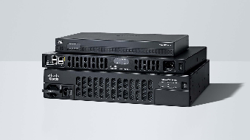 |  | Cisco ISR 4000 Series/k90  - Concurrent software services at speeds up to 10 Gbps (ISR4461). Backplane architecture supports high-bandwidth module-to-module communication at speeds up to 10 Gbps.  - Embedded Cisco Catalyst SD-WAN solution for creating lower-cost, business-class Internet connections  - Remote installation of application-aware services, which run identically to their counterparts in dedicated appliances. |  | 5042.29 | 2 | 10084.58
Switches  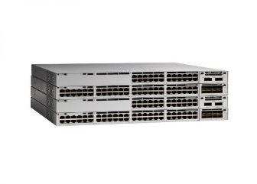 |  | C9300l-48t-4x-e,48-port 1G copper with fixed 4x10G/1G SFP+ uplinks, data only, Network Essentials  - With Stackwise-1T, Catalyst 9300 switches includes high-density stacking bandwidth solution with the most flexible uplink architecture.  - Flexible and dense uplink offerings with 100G, 40G, 25G, Multigigabit, 10G, and 1G modular uplinks.  - 48 mGig ports in standalone and 448 mGig ports with an 8-member stack. |  | 9307.78 | 5 | 46538.88
Firewalls |  | Cisco fpr2110-ngfw-k9  - Cisco Firepower NGIPS available which can passively detect endpoints and infrastructure for threat correlation and Indicators of Compromise (IoC) intelligence  - Cisco AMP for Networks, avaiable enables detection, blocking, tracking, analysis, and containment of targeted and persistent malware, addressing the attack continuum both during and after attacks. Integrated threat correlation with Cisco Secure Endpoint is also optionally available | 12500 | 1 |  | 12500
Access Points  (Wi-Fi) |  | C9130AXI-A  - 8x8 uplink/downlink MU-MIMO with eight spatial streams  802.11ax beamforming  - 20-, 40-, 80-, and 160-MHz channels  - PHY data rates up to 5.38 Gbps (8x8 80 MHz or Dual 4x4 80+80 MHz on 5GHz and 4x4 20 MHz on 2.4)  - CSD support  - WPA3 support |  | 2750 | 16 | 44000
NAS (Network Attached Storage)  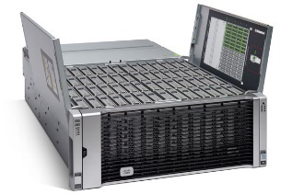 |  | Cisco UCS S3260  - Dual two-socket server nodes based on Intel® Xeon® Scalable processors or Intel E5-2600 v4 CPUs with up to 44 cores per server node  - Up to 1.5 TB of DDR4 memory per server node (3 TB total)  - Massive 960 TB data storage capacity that easily scales to Petabytes with UCS Manager  - Dual-port 40 Gbps System I/O Controllers with Cisco VIC 1300 Series Embedded Chip |  | 67608.59 | 1 | 67608.59
Servers  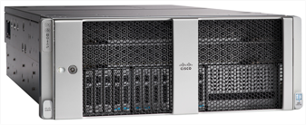 |  | Cisco UCS C480M5  - Memory speeds increase from 2666 MHz to 2933 MHz  - Up to 4 GPUs (2-CPU configuration) or 6 GPUs (4-CPU configuration) with offerings from NVIDIA and AMD  - Support for higher-density DDR4 memory, from 6 TB (128G DDR4 DIMMs) to 12 TB (256G DDR4 DIMMs) |  | 50000 | 3 | 150000
IoT Gateway  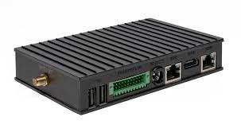 |  | Raspberry Pi 4 IoT Gateway  - Gigabit Ethernet for high-speed wired connectivity.  - Two USB 3.0 ports for high-speed devices.  - Two USB 2.0 ports for compatibility with other peripherals.  - Operating Systems: Runs Raspberry Pi OS (Linux-based) and other OS options like Ubuntu, or specialized IoT platforms like BalenaOS. |  | 300 | 3 | 900
Power & Cooling System
Uninterruptible Power Supply (UPS)  2 server room  2 database room  1 VCR  1 IOT  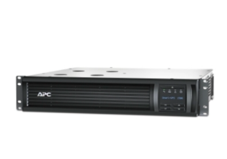 |  | APC Smart-UPS, Line Interactive, 1500VA, Rackmount 2U, 120V, 6x NEMA 5-15R outlets, SmartConnect Port+SmartSlot, AVR, LCD  - 1440VA/1000W line interactive pure sine wave 2U rackmount UPS  - Automatic Voltage Regulation helps correct utility voltage  - Cloud-based remote power monitoring via SmartConnect Ethernet Port |  | 4,201.00 | 6 | 25,206.12
Power Strips  GL1&2 10  SL 2  HC 4  VC 1  SR 1  DR 1  NOC 3  ESL 5  MR 1  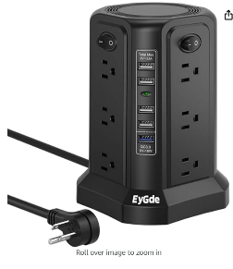 |  | Power Strip Tower Surge Protector, EyGde Electric Charging Station, 12 AC Outlets with 4 Individual ON/Off Switches, Flat Plug 6ft Long Extension Cord with 5 USB Ports (1 USB-A Quick Charge, 4 USB-A)  - Features 12 AC outlets and 5 USB ports (including 1 Quick Charge USB-A and 4 standard USB-A ports), allowing simultaneous charging of multiple devices.  - Tower design saves space and improves accessibility.  - Provides surge protection to safeguard devices from power spikes. |  | 323.00 | 28 | 12,920.00
Cooling Units (Server and Database room)  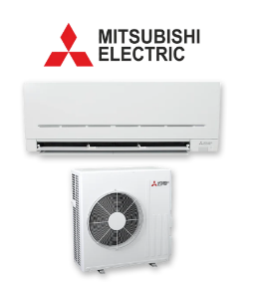 |  | Mitsubishi Electric MSZ-AP Series 7.1 kW Split System Air Conditioner MSZAP71VGD  - 7.1 kW cooling, suitable for medium to large spaces such as server rooms or open-plan areas.  - Equipped with an anti-allergy enzyme filter to improve air quality.  - Advanced inverter technology reduces energy consumption while maintaining consistent temperatures. |  | 7,800.75 | 4 | 31,203.00
Cabling & Wiring
Ethernet Cables (Cat6a)  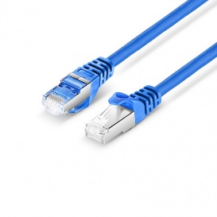 |  | Cat6a 26AWG Snagless Shielded (S/FTP) PVC CM Ethernet Network Patch Cable  - Up to 550MHz with 10G-T Speed, Support PoE/PoE+/PoE++ (IEEE 802.3af/at/bt)  - S/FTP Cable Minimizes EMI and RFI Interference |  | 11.50 | 1200m | 9200
Fiber Optic Cables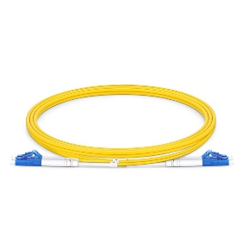 |  | Fiber Patch Cable, LC UPC to LC UPC, Single Mode (OS2)  - G.657.A1 Bend Insensitive Fiber & 10mm Min. Bend Radius  - Precision Zirconia Ferrule Connectors Ensure Low Loss  - OFNR Jacket for Vertical and Floor-to-floor Installations |  | 20 | 200m | 4000
Patch Panels  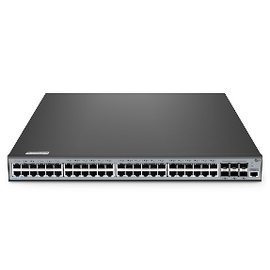 |  | S3900-48T6S-R, 48-Port Gigabit Ethernet L2+ Switch  - Stack Up to 8 Units on 10G Uplinks Ports with Up to 480G Bandwidth  - 1+1 Redundant Power Supplies and Dual Fans  - Support LACP, Voice VLAN, QoS, DHCP Snooping, etc. |  | 2126 | 5  (each lab installs 1) | 10630
Keystone Jacks  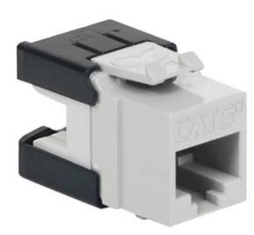 |  | ICC IC1078GAWH CAT6A RJ45 Keystone Jack  - Exceeds 500MHz transmission performance  - Fully supports 10Gig Ethernet applications (10GBASE-T)  - Compatible with CAT6, CAT5e, and voice network applications for versatility |  | 86 | 100 | 8600
RJ45 Connectors  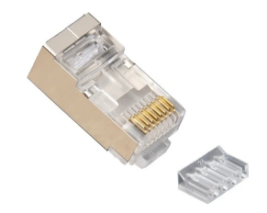 |  | Platinum Tools RJ45 SHIELDED CAT6 2PC CNNECTR  - Eight conductor mod plug with loading bar  - Uses 0.30mm (.012)  - 3 prong contact for solid conductors only |  | 6.18 | 200 | 1236
Conduits and Trunking  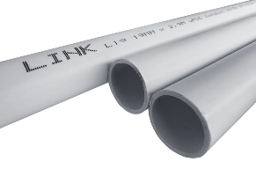 |  | LINK - White uPVC Wiring Conduit Pipe (L19W)  - Lightweight  - Moisture Resistance  - Smooth Inner Surface |  | 1.7 | 210 | 357
 | Lab/Classroom/Office Devices
PC(GL, HC)  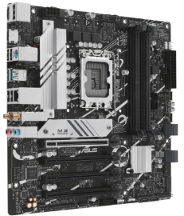 |  | - CPU: Intel Core i5-13500  - GPU: NVIDIA GeForce GTX 1650  - Motherboard: ASUS Prime B760M-A DDR4  - RAM: Corsair Vengeance DDR4 16GB (8GB x 2)  - Storage: Kingston NV2 1TB NVMe SSD  - Power Supply Unit (PSU): Cooler Master MWE 550W  - Case: Cooler Master MasterBox Q300L  - Operating System: Windows 11 Pro (Licensed) |  | 3660 | 93 | 340380
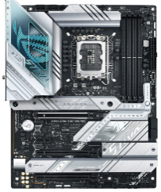  PC(CNL) |  | - CPU: Intel Core i7-13700K  - GPU: NVIDIA GeForce RTX 3060 Ti  - Motherboard: ASUS ROG Strix Z690-A Gaming  - RAM: Corsair Vengeance DDR4 32GB (16GB x 2)  - Storage: Samsung 970 EVO Plus 1TB NVMe SSD  - PSU: Seasonic Focus GX 750W  - Case: NZXT H510 (~RM 350)  - Operating System: Windows 11 Pro (Licensed) |  | 7150 | 31 | 221650
PC(ESL)  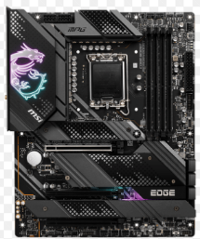 |  | - CPU: Intel Core i7-13700KF  - GPU: NVIDIA GeForce RTX 4060 Ti  - Motherboard: MSI MPG Z690 Edge WiFi  - RAM: Corsair Dominator Platinum 32GB (16GB x 2) DDR5  - Storage: WD Black SN850X 2TB NVMe SSD  - PSU: Cooler Master V850 Gold  - Case: Phanteks Eclipse P500A  - Operating System: Windows 11 Pro (Licensed) |  | 8400 | 31 | 260400
Smart TV  (1 – CNL,  1 – ESL,  1 – HC)  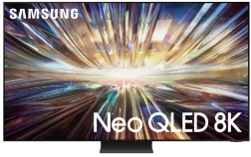 |  | Samsung Neo QLED 8K QN800D Tizen  OS Smart TV (2024)  - Display: 75”  - Refresh Rate: 100Hz  - Resolution: 8K (7,680 x 4,320)  - Video: NQ8 AI Gen2 Processor  - AI Upscale: 8K AI Upscaling  - Set Size with Stand (WxHxD): 1893.4 x 1153.4 x 303.7 mm |  | 20799 | 3 | 62397
Projector  (GL, Meeting Room)  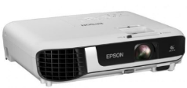 |  | PSON EB-X51 XGA 3800 Lumen 3LCD  - Display Technology: 3LCD (RGB liquid crystal shutter projection system)  - Brightness: White & Colour 3800 lumens  - Resolution: XGA (1024 x 768)  - Aspect Ratio: 4:3  - Contrast Ratio: 16,000:1  - Projection Size: 30” to 300” |  | 1899 | 5 | 9495
Speaker  (4 – 2 per GL  2 – HC  1 – CNL  1 – ESL  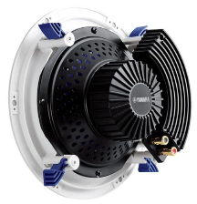  2 – MR) |  | Yamaha NS-IC800 Atmos Ceiling Speaker (Pair)  - Driver Size: 8-inch cone woofer with 1-inch tweeter  - Frequency Response: 50Hz to 28 kHz  - Sensitivity: 90 dB  - Power Handling: 120W (recommended)  - Impedance: 8 ohms |  | 1099 | 10 | 10990
Microphone  (1 per lab/classroom)  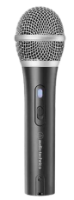 |  | Audio Technica ATR2100X-USB Cardioid Dynamic USB/XLR  - Lement: Dynamic  - Polar Pattern: Cardioid  - Frequency Response: 50-1.5k Hz  - Bit Depth: Up to 24 bit |  | 360 | 6 | 2160
PTZ Camera
(1 – Meeting Room)

3.3 Reflection

3.3.1 Are you surprised by the prices? How were you surprised?

3.3.2 Have you ever considered cost as a factor for choosing networking devices?
No, we prioritize the quality of all of the chosen devices to ensure that both devices meet all of the project’s functional and performance demands. To make an informed decision, we compare the device’s specifications, functions, and prices between the existing brands on the market, then we choose the most powerful and cost-effective one. If a device’s cost is exceeding our budget, we seek for an alternative option which offer similar features and performance with a more affordable price.

3.3.3 What are the major differences between the same devices from different
brands? For example, Cisco and Huawei Routers.

Router
Server

PC (Personal Computer)
For PC, a powerful processor allows a PC perform multitasking and productivity tasks smoothly and effectively. For the important lab like CNL and ESL, Intel Core i7-13700K processor will be used in the PC for each workstation. The alternative one is AMD Ryzen 7 7800X3D.
Specification | Inter Core i7-13700K | AMD Ryzen 7 7800X3D
Cores/Threads | 16/24 | 8/16
Base Clock Speed | 3.4 GHz | 4.2 GHz
Max Boost Clock Speed | 5.4 GHz | 5.0 GHz
L3 Cache | 30 MB | 96 MB
Integrated Graphics | Yes | No
Price (Approx.) | RM 1580.00 | RM 2500.00
The Intel Core i7-13700K provides more cores and threads, which can enhance better multitasking and productivity tasks, which is essential for academic labs to handle multiple simulations and design task simultaneously. Moreover, it includes integrated graphic which provides flexibility if a discrete GPU isn’t available. Even though AMD Ryzen 7 7800X3D has larger L3 cache and base speed, but considering overall versatility and performance, Intel Core i7-13700K will be a more efficient choice.

Smart TV
A Smart TV is essential to display high-quality video conferencing and multimedia presentations. For our plan, we will use Samsung QN800D Neo QLED 8K, while the alternative one will be LG Z3 8K OLED TV.
Specification | Samsung QN800D Neo QLED 8K | Sony BRAVIA 9 85-inch Mini LED QLED 4K Ultra HD 120Hz Smart TV (Google TV) 2024
Display Technology | Neo QLED (Mini LED) | Mini LED QLED
Resolution | 8K (7680x4320) | 4K Ultra HD (3840x2160)
HDR Support | HDR10+, HLG | HDR10, Dolby Vision, HLG
Operation System (OS) | Tizen OS | Google TV
Refresh Rate | 120Hz | 120Hz
Audio | 70W 4.2.2 channel with Dolby Atmos | Multi-directional speakers with Dolby Atmos
Price (Approx.) | RM 20799.00 | RM 24399.00

Samsung QN800D Neo QLED 8K has a higher resolution which is 8K, which provides superior clarity for detailed technical presentations which is beneficial in lab and classroom. Moreover, it equipped with a 70W 4.2.2 channel sound system featuring built-in up, down, and side-firing speakers with True Dolby Atmos support which can deliver immersive audio experiences which enhance engagement during lectures.

Projector
A projector is crucial to display presentation, and collaborative contents. The Epson EB-X51 XGA 3800 Lumens 3LCD Projector will be used due to its excellent resolution and brightness. The alternative one is BenQ MS560 SVGA 4000 Lumens Projector.
Specification | EB-X51 XGA 3800 Lumens 3LCD Projector | BenQ MS560 SVGA 4000 Lumens Projector.
Resolution | XGA (1024x768) | SVGA (800x600)
Brightness | 3800 lumens | 4000 lumens
Price (Approx.) | RM 1899.00 | RM 1499.00
Comparing to BenQ MS560 SVGA 4000 Lumens Projector, EB-X51 XGA 3800 Lumens 3LCD Projector has higher native resolution, which provides sharper image quality. This is essential for academic and professional presentations. Although it is more expensive than the BenQ MS560 SVGA 4000 Lumens Projector, it’s specification can meet the demands for the hybrid classroom and general-purpose labs.

Speaker
High-quality speakers needed for each classroom and lab in the building. In our plan, Yamaha NS-IC800 Atmos Ceiling Speaker (Pair) will be installed in each classroom and labs, while Polk Audio RC80i Ceiling Atmos speakers will be the alternative,
Specification | Yamaha NS-IC800 Atmos Ceiling Speaker (Pair) | Polk Audio RC80i Ceiling Atmos speakers
Speaker Type | In-ceiling, Atmos-ready | In-ceiling, Atmos-ready
Frequency Response | 50Hz – 28kHz | 35Hz – 20kHz
Sensitivity | 90 dB | 90 dB
Power Handling | 140W (Max) | 100W (Max)
Price (Approx.) | RM 1099.00 | RM 1299.00
Compare to Polk Audio RC80i, Yamaha NS-IC800 has a wider frequency range (50Hz – 29kHz), which allow it to capture finer audio details which is beneficial for technical presentations and lectures. Furthermore, Yamaha NS-IC800 has a higher maximum power capacity of 140W, which suitable for larger spaces. Also considering the price, Yamaha NS-IC800 will be more cost-effective while provide better performance.

Microphone
A reliable and high-quality microphone is important for each lab and classroom to ensure clear and sharp audio for video conferencing and lectures. In our plan, we will use Audio Technica ATR2100X-USB Cardioid Dynamic USB/XLR, the alternative one will be Samson Q2U Handheld Dynamic USB.
Specification | Audio Technica ATR2100X-USB Cardioid Dynamic USB/XLR | Samson Q2U Handheld Dynamic USB
Polar Pattern | Cardiod | Cardiod
Frequency Response | 50Hz – 15kHz | 50Hz – 15kHz
Connectivity | USB-C, XLR | USB, XLR
Bit Depth/Sample Rate | 24-bit/192kHz | 16-bit/48kHz
Price (Approx.) | RM 360.00 | RM 390.99
Both microphone has similar price, but Audio Technica ATR2100X-USB supports 24-bit/192kHz which provide superior audio clarity and precision for live communication, which is important for technical explanation and presentation. Moreover, it includes USB-C which ensures better compatibility with modern devices. Therefore, with a lower cost, Audio Technica ATR2100X-USB will be our first choice.

